Testing document for MS Decom activities

Project: z_i740_aqpl

System : xFE

CD: 151938.

Transport request: DFEK962733

—---------------------------------------------------------------------------------------------------------------------------------

Testing the changes with below data and extracted google sheet by using all the 4 buttons.

For this app we need to enable the Export to XLSX option as well for external users.

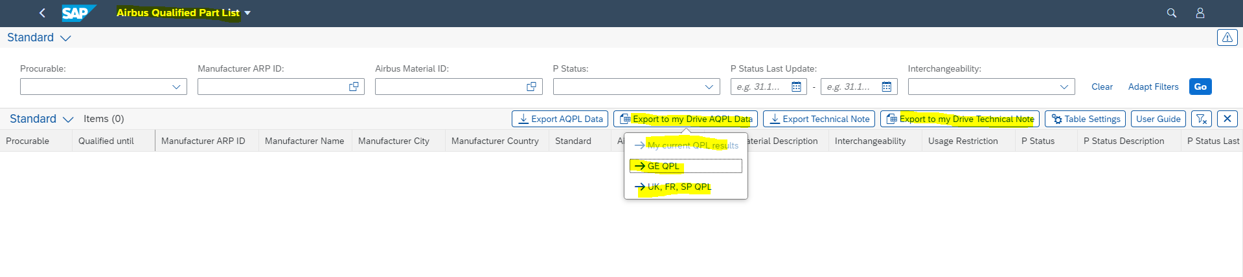

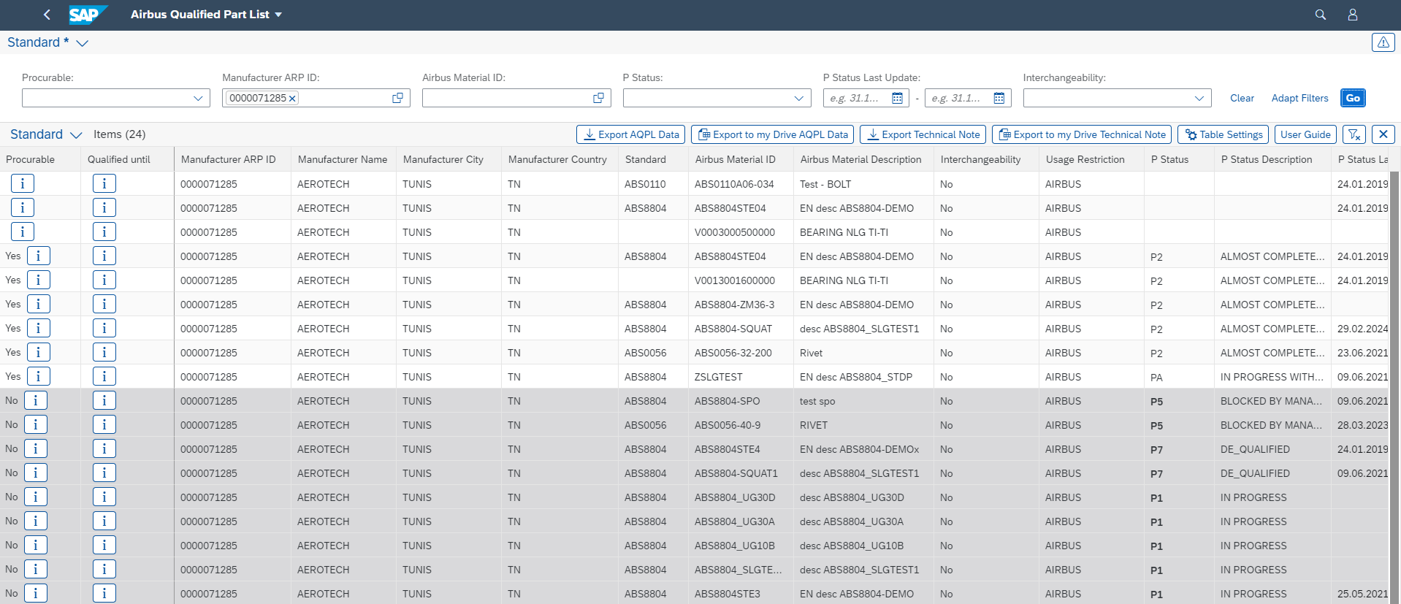

1. Export to my Drive Technical Note:

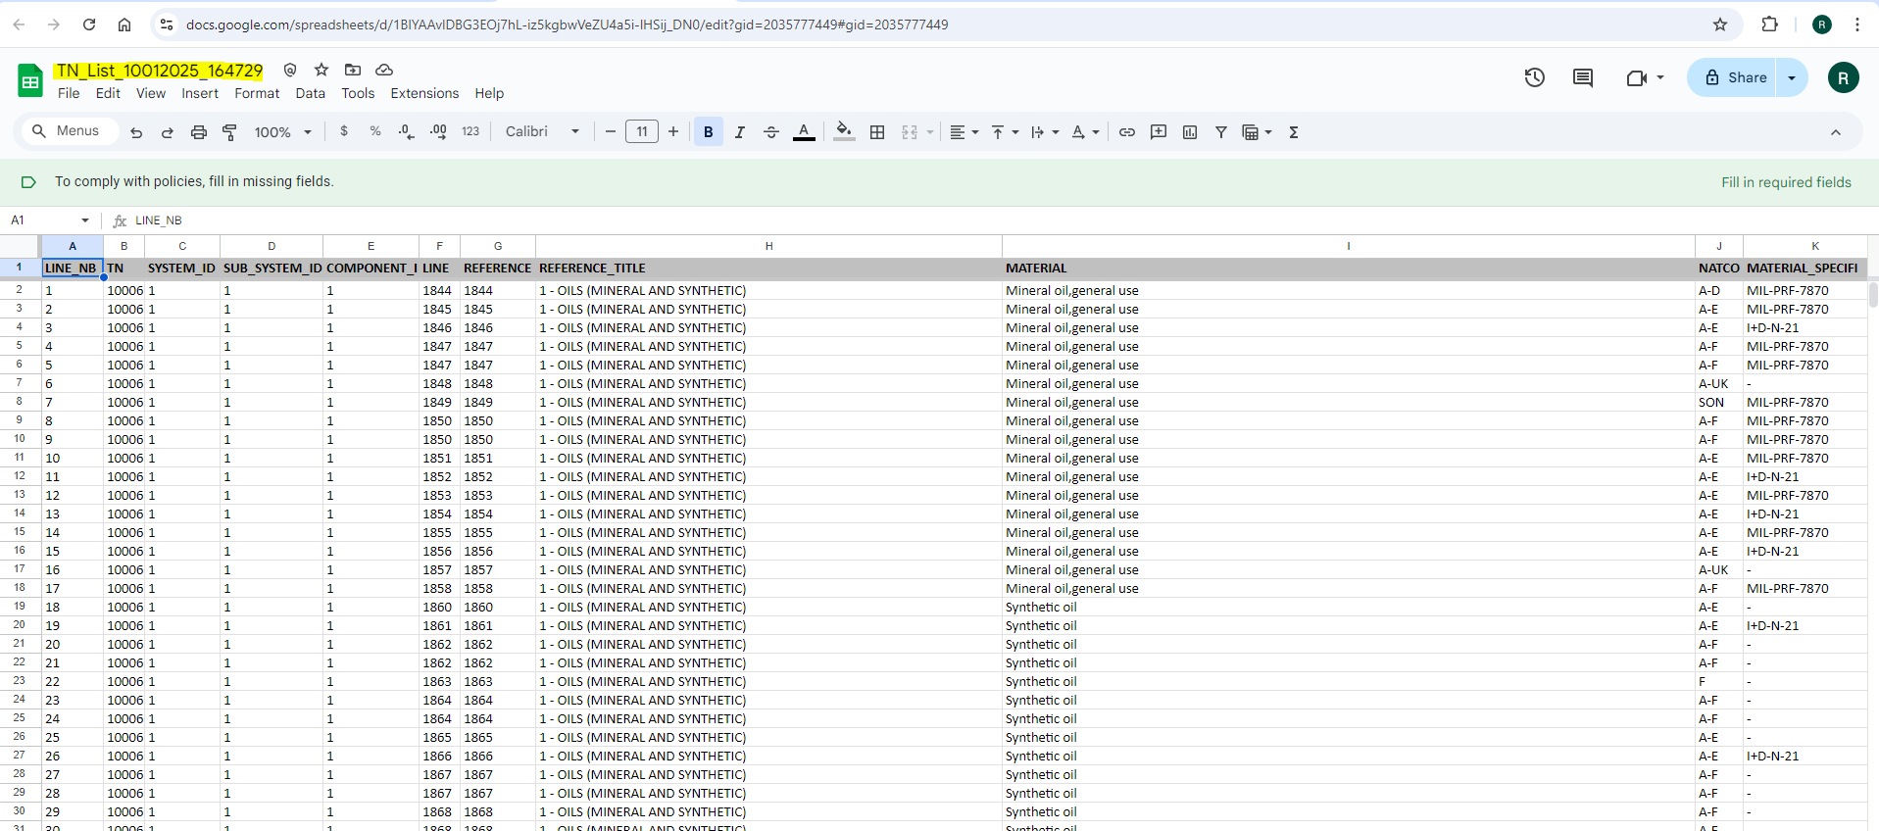

1. My current QPL Results:

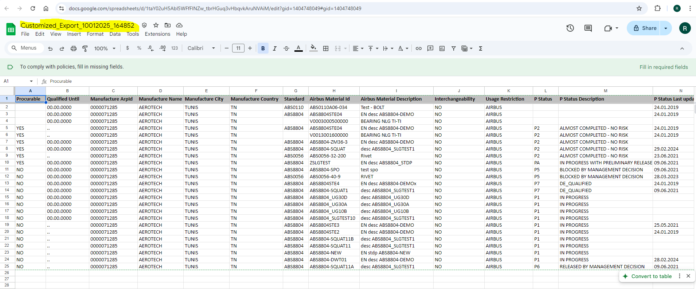

1. GE QPL:

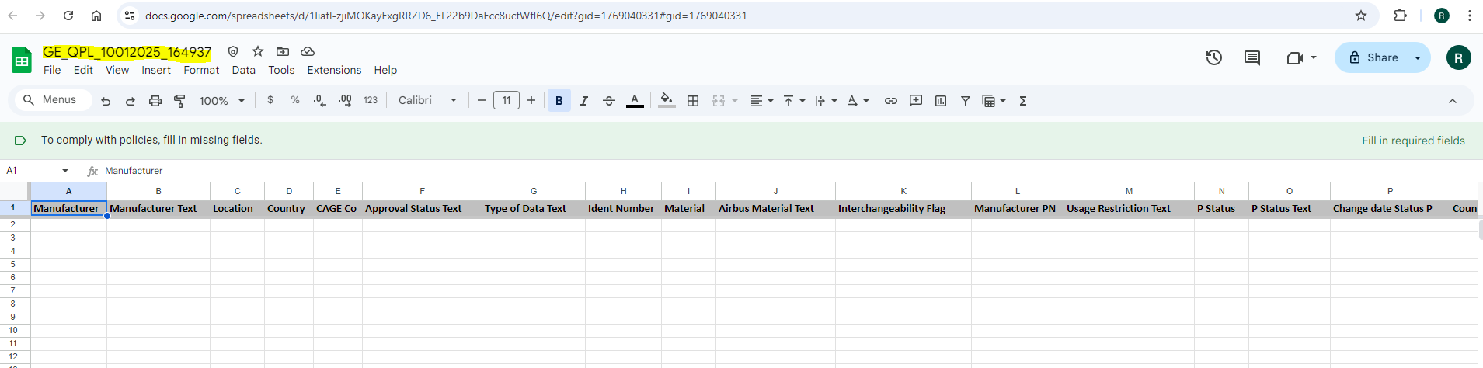

1. UK, FR, SP QPL:

